

- LIGHT ENERGY

Light is a form of energy and without light from the sun the world would not only be in complete darkness, but plants would not grow and all other life on Earth would not exist.

Demonstration: Light is Energy

A demonstration using Crookes radiometer can show that light is a form of energy.

Describe what happened when light was shone on a Crookes radiometer.

_____________________________________________________________________

_____________________________________________________________________

What does this demonstration show?

_____________________________________________________________________

Describe the energy change that is taking place.



Other examples of energy changes are ;

a) Phototsynthesis LIGHT ⇒ CHEMICAL

b) Sight LIGHT ⇒ CHEMICAL ⇒ ELECTRICAL

c) Photovoltaic cell LIGHT ⇒ ELECTRICAL

2. THE ELECTROMAGNETIC SPECTRUM

Light is a type of wave. It is part of a large group of waves called the electromagnetic spectrum.
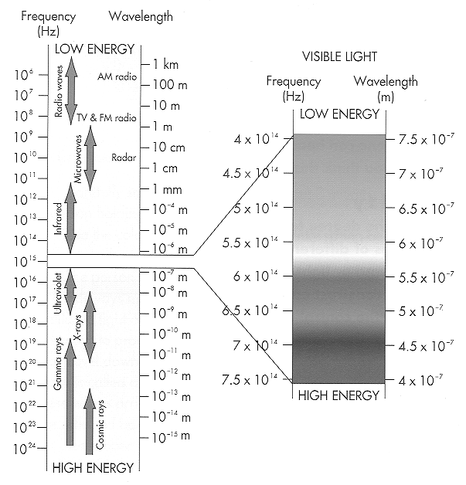

A chart of the electromagnetic spectrum. Note that the visible spectrum is only a small portion of the whole electromagnetic spectrum. The broadcast band ranges from approximately 50 to 500 metres in wavelength. Colour in the colours in order for the section for visible light

Electromagnetic waves require no medium and they all travel at the same speed in space.

A small beam of white light consists of a very large number of individual waves of many different wavelengths. The waves travel together in a straight line.

The diagram below shows different wavelengths emitted from a globe. Indicate in the diagram, the colour corresponding to each wavelength.

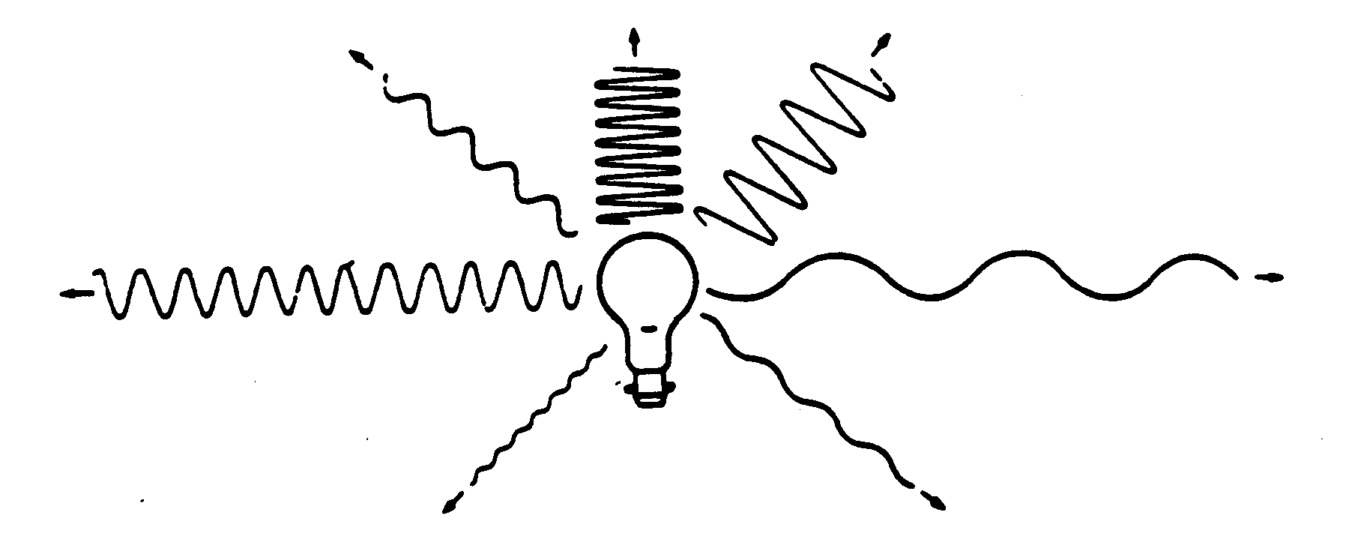
Examine the materials at Station 1. They have different properties with respect to light. Some are opaque, some are transparent and some are translucent. Describe what happens to light when light is incident on each type of material. Write your descriptions in the spaces below.

Transparent;___________________________________________________________

_____________________________________________________________________

Translucent;___________________________________________________________

_____________________________________________________________________

Opaque;______________________________________________________________

_____________________________________________________________________

3. SHADOWS

Go to Station 2 and examine the demonstration which has been set up. You will notice there are two different types of shadows. One is very dark and well defined. The other is not as dark and it is ill defined around the edges.

A shadow is ___________________________________________________________________

Explain how the well defined shadow is formed (mention type of light source).
_____________________________________________________________________

_____________________________________________________________________

Explain how the ill defined shadow is formed (mention type of light source).
_____________________________________________________________________

_____________________________________________________________________

What are these two types of the shadows called?

Well defined shadow

____________________________________________________________________

Ill defined shadow

____________________________________________________________________

4. LUMINOUS AND NON-LUMINOUS BODIES

Describe the difference between a luminous body and a non-luminous body (give examples)

_____________________________________________________________________
_____________________________________________________________________
_____________________________________________________________________
_____________________________________________________________________
_____________________________________________________________________
_____________________________________________________________________
_____________________________________________________________________

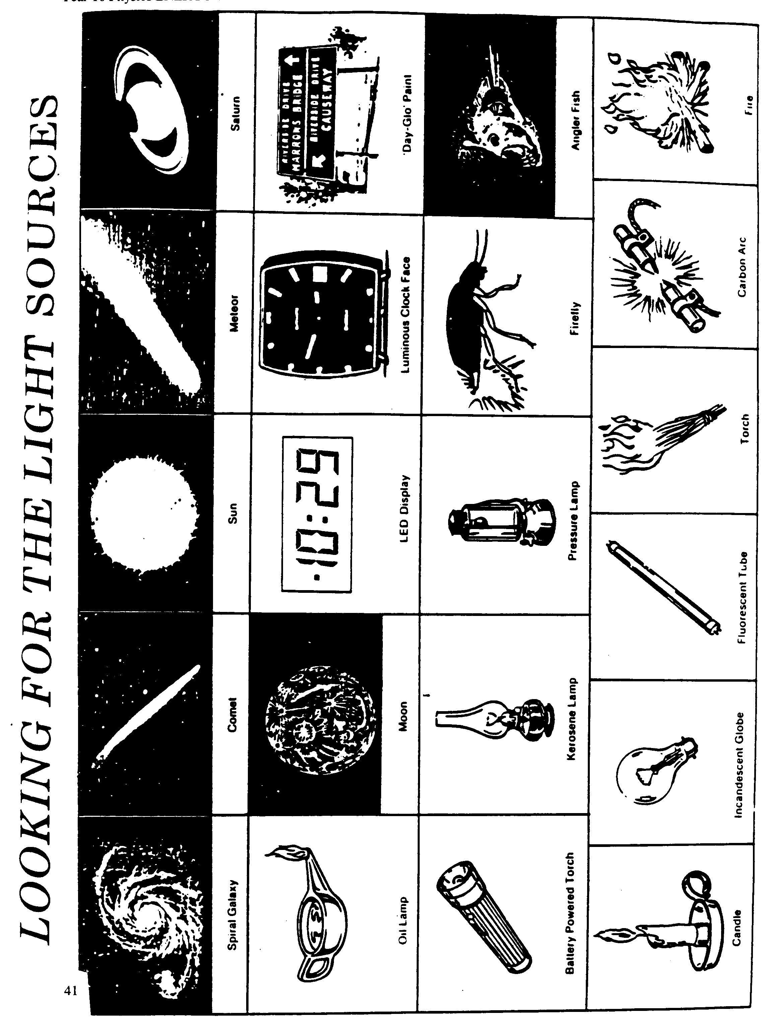

ACTIVITY : Sorting them out!

Classify the pictures on the previous page as luminous and non- luminous

LIGHT SOURCES

LUMINOUS | NON-LUMINOUS

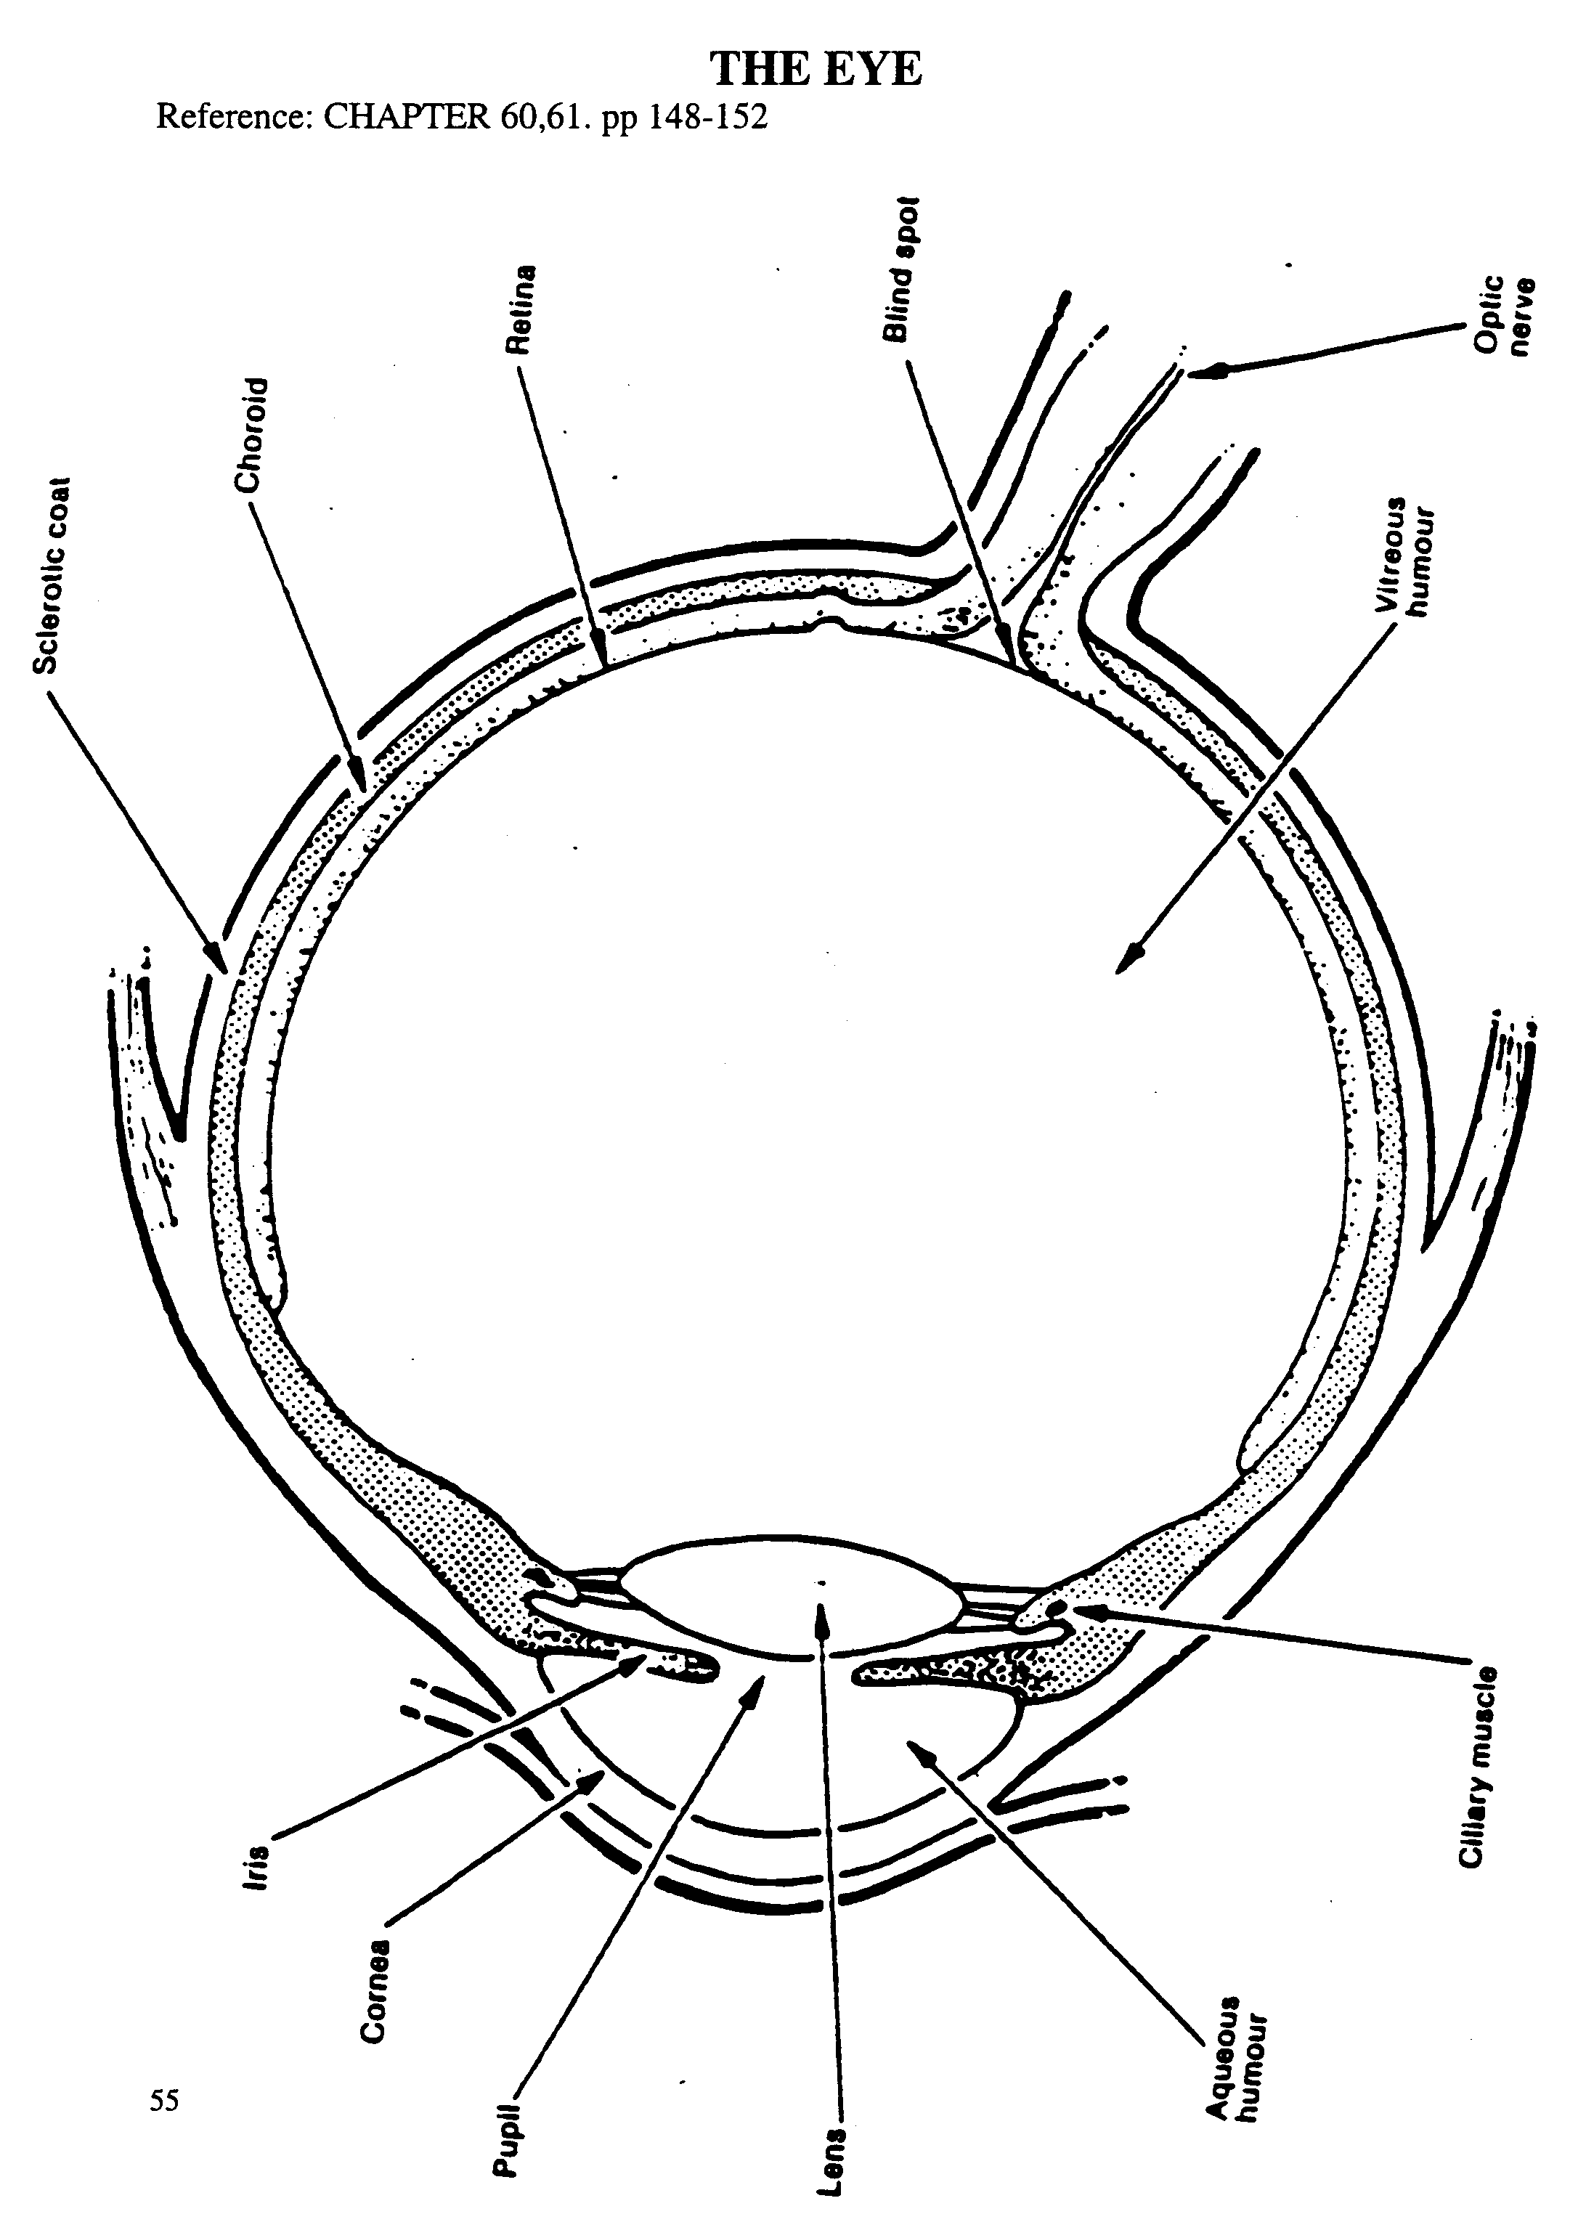
5. THE EYE
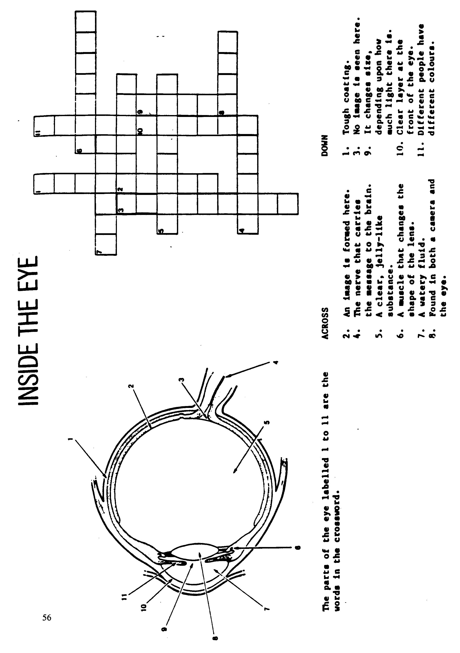

6. SEEING AND BELIEVING

ACTIVITY : Optical illusions

Method:
Observe each of the diagrams below and record your observations.

1.
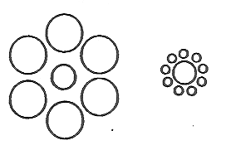
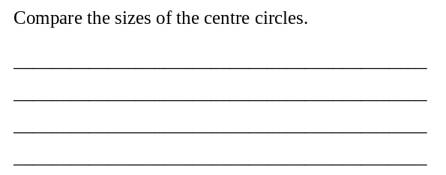


Observe the shading on each side of the bands. Isolate each band and see if you still think there is a difference.
________________________________________________________________________________________________________________________________________________________________________________
2.

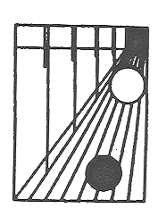
3.
Which of the two shapes is larger? Describe the position of the two balls.

____________________________________________________________________________________________________________________________________________________________________________

4.
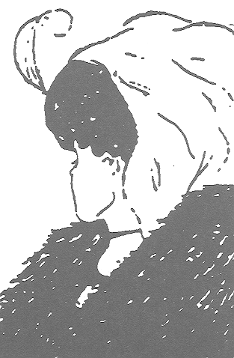
Is the woman young or old?

________________________________________________________________________________________________________________________________________________________________________________

5.
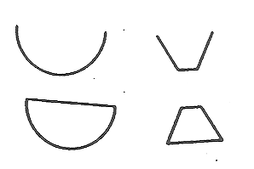
Compare the open and closed figures. How could this influence your judgement of how much a container holds?
________________________________________________________________________________________________________________________________________________________________________________________

6.
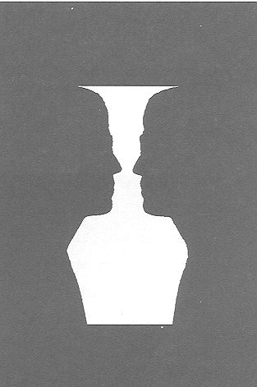
What do you see?

_____________________________________________________________________________________________________________________________________________

7.
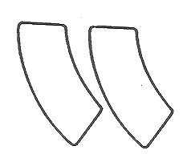
Which swimming pool is larger? Check your answer by tracing the outline of one pool and placing it over the drawing of the other pool.

______________________________________________________________________________________________

ACTIVITY : A-maze-ing Mirrors

Method:
You will need to get a plane mirror and place the maze flat in front of it. Look at the image of the maze and use a pencil to follow the maze without crossing the lines. Do not look at the maze itself. (You may like to get a friend to hold a card up so that you can only see the image.)



